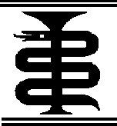



-







- -

2012



2

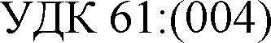

-49

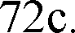

-

-

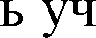

-

-

-

-

*-*

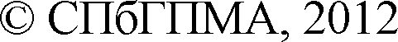

# 1 Office Access



Microsoft Office Access **-**

**)**

Microsoft

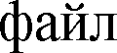

VBA (Visual Basic for Applications)

MS Access

**-**

.

MS

**-**

Access

**1 ** **Microsoft Office Access**

.



  **Microsoft Office**.

**Microsoft Office Access **).



# 1



MS Access

 .

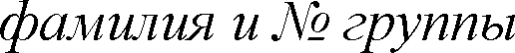

)



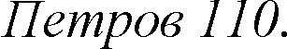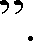

**.accdb**

*accdb*

**1 ** 

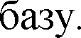

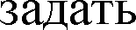





## -



 

,



**Enter**

, , , , .





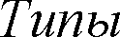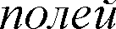*Microsoft Office Access*

|  |  |
| --- | --- |
|  |  |
|  |  |
|  |  |
|  |  |
|  |  |
|  |  |
|  |  |
|  |  |
|  |  |
|  |  |





.

.



.



.

 . 



## 000-00-00.

  



       



.

.

4



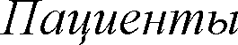.

|  |  |  |  |  |  |  |  |
| --- | --- | --- | --- | --- | --- | --- | --- |
|  |  |  |  |  |  |  |  |
| 01 |  | 01.09.1994 | 54 | 113-45-66 |  |  |  |
| 02 |  | 01.03.1994 | 42 | 119-21-34 | Lloyd's |  |  |
| 03 |  | 01.04.1994 |  | 113-45-78 |  |  |  |
| 04 |  | 01.05.1995 |  | 111-55-59 |  |  |  |
| 05 |  | 01.05.1996 | 14 | 112-35-62 | Lloyd's |  |  |
| 06 |  | 04.06.1997 | 37 | 111-25-63 | Lloyd's |  |  |
| 07 |  | 09.10.2007 | 32 | 113-15-64 |  |  |  |
| 08 |  | 11.12.2007 | 61 | 112-75-66 | Lloyd's |  |  |
| 09 |  | 14.07.2008 | 33 | 114-85-67 | Lloyd's |  |  |
| 10 |  | 15.03.2008 | 10 | 114-95-69 |  |  |  |



, .

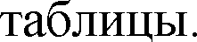

.







|  |  |  |
| --- | --- | --- |
|  |  |  |
| 011 |  | 6 - 12 |
| 012 |  | 1 |
| 013 |  | 6 |
| 021 |  | 3 - |
| 022 |  | 7 |
| 023 |  | 14 |
| 031 |  | 3 - 6 |
| 032 |  | 18 |
| 033 | II | 7 |

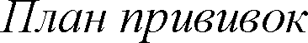

|  |  |  |
| --- | --- | --- |
|  |  |  |
| 011 | 01 | 01.09.1994 |
| 012 | 01 | 02.10.1994 |
| 013 | 01 | 02.03.1995 |
| 021 | 01 | 04.09.1995 |
| 022 | 01 | 01.03.1995 |
| 023 | 01 | 01.02.2008 |
| 031 | 01 | 01.12.1994 |
| 032 | 01 | 01.12.1995 |
| 033 | 01 | 01.12.2009 |
| 011 | 02 | 04.09.1994 |
| 012 | 02 | 04.09.2001 |
| 013 | 02 | 02.03.1995 |
| 021 | 02 | 01.09.1994 |
| 022 | 02 | 02.10.1994 |
| 023 | 02 | 01.02.2008 |
| 011 | 03 | 01.12.1994 |
| 012 | 03 | 02.10.1994 |

|  |  |  |
| --- | --- | --- |
| 013 | 03 | 08.06.2003 |
| 011 | 05 | 30.05.1996 |
| 012 | 05 | 29.06.1996 |
| 013 | 05 | 28.02.1997 |
| 021 | 05 | 20.03.2002 |
| 022 | 05 | 24.03.2009 |
| 023 | 05 | 21.03.2016 |
| 031 | 05 | 29.11.1996 |
| 032 | 05 | 29.01.1998 |
| 033 | 05 | 28.12.2003 |
| 011 | 06 | 04.06.1997 |
| 012 | 06 | 04.07.1997 |
| 021 | 06 | 11.06.1997 |
| 022 | 06 | 04.06.2004 |
| 011 | 07 | 10.10.2007 |
| 012 | 07 | 11.11.2007 |
| 013 | 07 | 12.05.2008 |
| 011 | 08 | 11.12.2007 |
| 012 | 08 | 12.01.2008 |
| 013 | 08 | 11.07.2008 |
| 011 | 10 | 16.03.2008 |



|  |  |  |
| --- | --- | --- |
|  |  |  |
| 011 | 01 | 01.09.1994 |
| 011 | 05 | 01.05.1996 |
| 011 | 06 | 04.06.1997 |
| 011 | 07 | 09.10.2007 |
| 011 | 08 | 11.12.2004 |
| 011 | 10 | 15.03.2008 |
| 012 | 01 | 04.09.2001 |

|  |  |  |
| --- | --- | --- |
| 012 | 05 | 02.05.1996 |
| 012 | 06 | 07.07.1997 |
| 012 | 07 | 11.11.2007 |
| 012 | 08 | 12.01.2005 |
| 013 | 01 | 08.12.2004 |
| 013 | 05 | 01.07.1996 |
| 013 | 07 | 12.06.2008 |
| 021 | 01 | 10.08.1996 |
| 021 | 02 | 16.03.2008 |
| 021 | 03 | 01.05.1996 |
| 021 | 05 | 04.05.1996 |
| 021 | 06 | 11.06.1997 |
| 022 | 01 | 12.09.1997 |
| 022 | 02 | 21.06.2008 |
| 022 | 03 | 04.06.1998 |
| 022 | 05 | 06.08.1996 |
| 022 | 06 | 04.06.2004 |
| 023 | 01 | 15.01.2008 |
| 023 | 02 | 01.09.2008 |
| 023 | 03 | 09.10.2008 |
| 031 | 01 | 11.12.2007 |
| 031 | 05 | 01.03.1996 |
| 032 | 01 | 15.03.2008 |
| 032 | 05 | 02.05.1996 |





 



  







.

**,**

**-**



     



.



,

.



**1**,



.

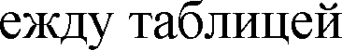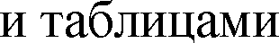

,



# 1

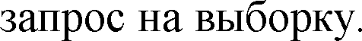

**-**

.

9

# 1

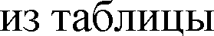

,

.





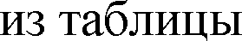 , 

  







.

 .



).

 

   

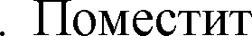

**05**.

# 1



,

,



, , 

 .

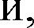

,





**>**



.



.

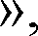.



 .

 . 



.

10

# 1.5.3.

,

.

,

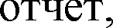

.

 

.



.

:

# 1

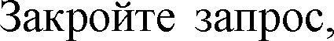

.





,

,





    

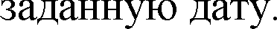

# 1



 

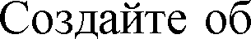

, 

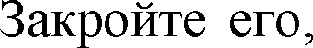

.

.

  

**-** .

**_1**

.



11

     



.



.

   .



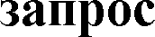**-** .

# 1



 



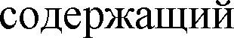,

.





.

.



# 1







.



 .



12













.



, **Count**



, **Count** .



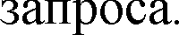 **Count**







**[ ]![Count-**

**Count**



 

## Nz

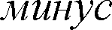

**[ ]![Count-**



**Nz([ ]![Count- )**.

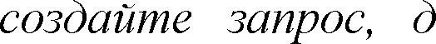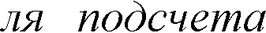

**?**

.



# 1.6.



 .  

.



, 



 . .

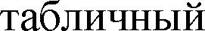,



,

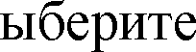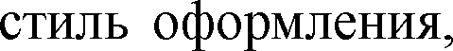

**- **

.

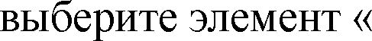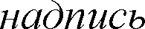

## Enter.



**.**

.

.

   

  





.



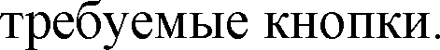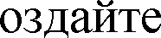

**?**

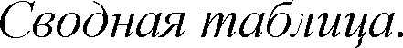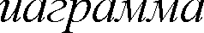

# 1



   **-**

.



 , , , ,



, , 

.







**OK**

.

   

.



 **-**



 .







**?**

:



# 1

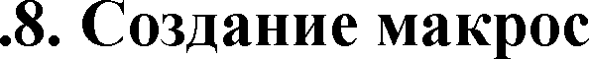

**-**



 .



.

.



 .

 .

15



,

 ,



.



  



.



.

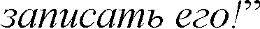

 **Tab**.



,

,

.





 .

 .



.

# 1.9.

 VBA (Visual Basic for Applications) Microsoft Office Access



. **-**

VBA.

 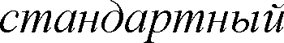 

 



*Module1*.

**-** .

**Visual Basic**



**Code**



## Option Compare Database Option Explicit



**Option Compare Database** MS

## Option Explicit



**Declarations**

(

**Option**

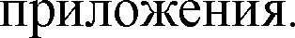

**ShowMessage**.





## Insert > Procedure Visual Basic.

**Add Procedure**.

## ShowMessage



**Sub Type Public Scope**.





## Sub End Sub

**ShowMessage**

*Dim MsgTxt As String*

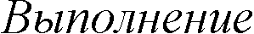*MsgTxt = " 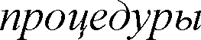* *ShowMessage." Beep*

*MsgBox MsgTxt, vbInformation, "ShowMessage Procedure"*

## Code.

**ShowMessage**



## Visual Basic Immediate Window, Ctrl+G,

**ShowMessage Enter ShowMessage**



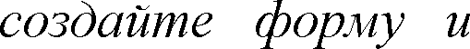



# 2 Office Excel

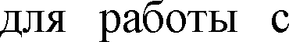Microsoft Office Excel **-**

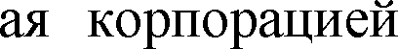

,

Microsoft

Microsoft Windows

**-**

VBA (Visual Basic for Applications).



# 2.1

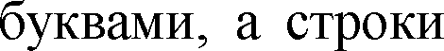

Excel



**D6**

**D**

**6**

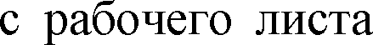**D6**

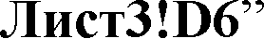

**D6**.

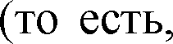

.

Excel

**=D6**)

**A1**

**B3**

Excel

**=E8**.



**$ -**

**= D6**, **= $D6**, **= D$6**, **= $D$6**).



**!**

# 2.2



**Delete**

**-**

.



**/**

**/** .

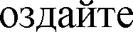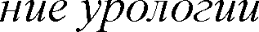

|  |  |  |  |  |
| --- | --- | --- | --- | --- |
|  | A | B | C | D |
| 1 |  |  |  |  |
| 2 | 1 |  | 145 |  |
| 3 | 2 |  | 132 |
| 4 | 3 |  | 234 |
| 5 | 4 |  | 173 |
| 6 | 5 |  | 108 |
| 7 | 6 |  | 123 |
| 8 |  | |  |

|  |  |  |  |  |  |
| --- | --- | --- | --- | --- | --- |
|  | | | | . | **A2** |
| **1**  **3** | **A2.** | **2**. | **A3** | =  **+1**.  **=A2+1**.  **3** | **Enter.** |

## A3





   

**A4 - A7.**



**A7**

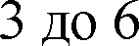

 **A4 - A7** .

  **B2 - B7**

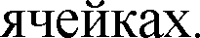







## C2 - C7

      

.



**-**

.



!

## C2 - C7



 **D2 - D8 ** **D2**

 

**Enter**. .

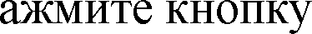

 **B2 -**

**2**.



.

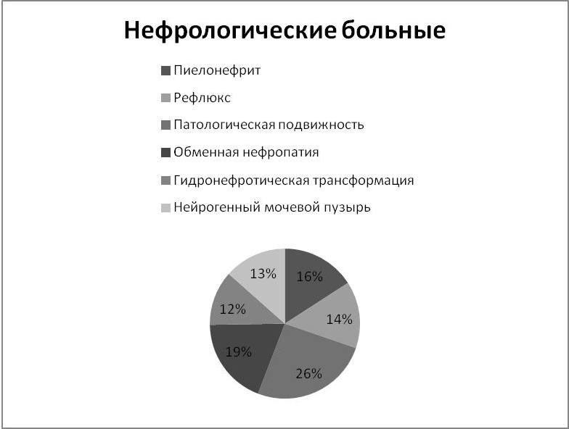

20



 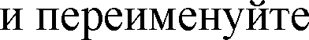 .

 **B2 - I2** ,



## B2



.

,

,

.

. 

   

## C2 - I2

.

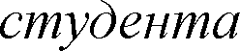

|  |  |  |  |  |  |  |  |  |  |  |
| --- | --- | --- | --- | --- | --- | --- | --- | --- | --- | --- |
|  | A | B | C | D | E | F | G | H | I | J |
| 1 |  |  | | | | | | | |  |
| 2 |  |  |  |  |  |  |  |  |
| 3 |  | | | | | | | |
| 4 |  |  |  |  |  |  |  |  |
| 5 | 1 |  |  |  |  |  |  |  |  |  |
| 6 | 2 |  |  |  |  |  |  |  |  |  |
| 7 | 3 |  |  |  |  |  |  |  |  |  |
| 8 | 4 |  |  |  |  |  |  |  |  |  |
| 9 | 5 |  |  |  |  |  |  |  |  |  |
| 10 | 6 |  |  |  |  |  |  |  |  |  |
| 11 | 7 |  |  |  |  |  |  |  |  |  |
| 12 | 8 |  |  |  |  |  |  |  |  |  |
| 13 | 9 |  |  |  |  |  |  |  |  |  |
| 14 |  | |  |  |  |  |  |  |  |  |
| 15 |  | |  | | | | | | | |
| 16 |  | |  | | | | | | | |
| 17 |  | |  | | | | | | | |
| 18 |  | | |  | | | | | | |

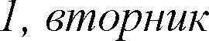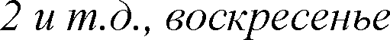

**B4 I4**

 (

*- 7*). **B4**.

.

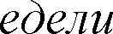

**B2**,

*,*

)

**B4**

.

**C4 - I4**



## 3



**B5 B13**

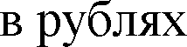



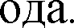

## I13

.









**5**

).

 **7**



**6**



**D18 -**

**J18**

.

**6**

**7**

,

## - J18



:

**D18**



    



# 2.4.

 .



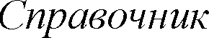.

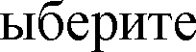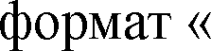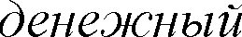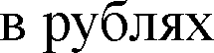

.

c

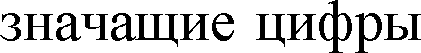

|  |  |  |  |  |  |  |
| --- | --- | --- | --- | --- | --- | --- |
|  | A | B | C | D | E | F |
| 1 |  | | | |  | |
| 2 |  |  |  |  |  |  |
| 3 | -145 |  |  |  |  | 10% |
| 4 | -245 |  |  |  |  | 50% |
| 5 | -301 |  |  |  |  | 30% |
| 6 | -371 |  |  |  |  | 0% |
| 7 | -429 |  |  |  |  |  |



**-**

.

  

**-** ,



**C3 - C7**

**E3 - E6**,

, .



**D3**, **D4 D7**



 

**E3 - F6**.



.

## A2 - C7.





  





|  |  |  |  |  |  |  |  |  |
| --- | --- | --- | --- | --- | --- | --- | --- | --- |
|  |  |  |  | D | E | F | G | H |
| 1 |  |  |  |  |  |  |  |  |
| 2 |  |  |  |  |  |  | 20 |  |
| 3 |  |  |  |  |  |  | 19 |  |
| 4 |  |  |  |  |  |  | 25 |  |
| 5 |  |  |  |  |  |  | 18 |  |
| 6 |  |  |  |  |  |  | 30 |  |
| 7 |  |  |  |  |  |  | 26 |  |
| 8 |  |  |  |  |  |  | 29 |  |
| 9 |  |  |  |  |  |  | 16 |  |
| 10 |  |  |  |  |  |  | 20 |  |
| 11 |  |  |  |  |  |  | 25 |  |
| 12 |  |  |  |  |  |  | 25 |  |
| 13 |  |  |  |  |  |  | 25 |  |
| 14 |  |  |  |  |  |  | 30 |  |
| 15 |  |  |  |  |  |  | 19 |  |
| 16 |  |  |  |  |  |  | 24 |  |
| 17 |  |  |  |  |  |  | 20 |  |
| 18 |  |  |  |  |  |  | 21 |  |
| 19 |  |  |  |  |  |  | 34 |  |
| 20 |  |  |  |  |  |  | 33 |  |
| 21 |  |  |  |  |  |  | 35 |  |

.  **-**

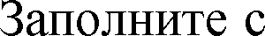

...

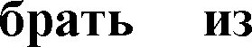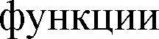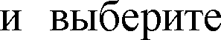

).

;

; .



**F3**.





  .

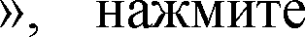

**F3**



**-** ;

**F3**); **3**;

**0**.

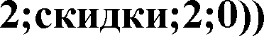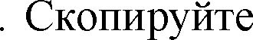

**E2**

: **=**

**-**

**D**

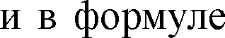

**E6**

.

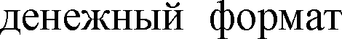

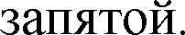

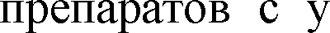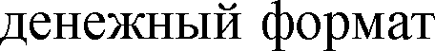

**H2**

**=E2*G2**

# 2

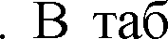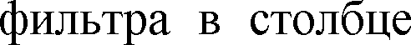

.

.

.



,

25



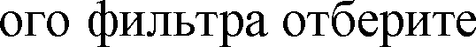

.



**-**

 





 .



**D2 - F2**



  **-**

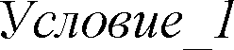 **- .**



**F3**

**F3**

**_1**

**D2 - F2**

.



|  |  |  |  |  |  |  |
| --- | --- | --- | --- | --- | --- | --- |
|  | A | B | C | D | E | F |
| 1 |  | |  |  | | |
| 2 |  |  |  |  |  |  |
| 3 |  | >8000 |  |  |  |  |

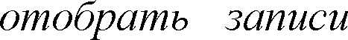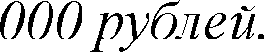

**?**

*3*

# 2.6

## 7

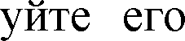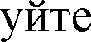

  



**1, 2**

**3**

**-**

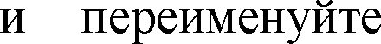

**-**

.

**8**

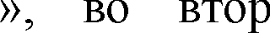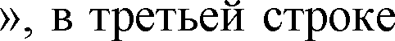

.

.



# 2.7



**9**



## 2

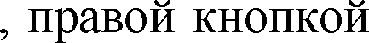

**-**

**-**

.



 **- ** **-**

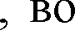

**OK**.

.

.

# 2.8



**10**







 



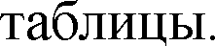

 



**2**

.



27









  



,



.



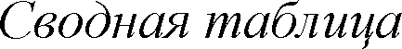

|  |  |  |  |  |  |  |  |  |
| --- | --- | --- | --- | --- | --- | --- | --- | --- |
|  | A | B | C | D | E | F | G | H |
| 1 |  |  |  |  |  |  |  |  |
| 2 |  |  |  |  |  |  |  |  |
| 3 |  |  |  |  |  |  |  |  |
| 4 |  |  |  |  |  |  |  |  |
| 5 |  |  |  |  |  |  |  |  |
| 6 |  |  |  |  |  |  |  |  |
| 7 |  |  |  |  |  |  |  |
| 8 |  |  |  |  |  |  |  |
| 9 |  |  |  |  |  |  |  |  |
| 10 |  |  |  |  |  |  |  |
| 11 |  |  |  |  |  |  |  |
| 12 |  |  |  |  |  |  |  |  |
| 13 |  |  |  |  |  |  |  |
| 14 |  |  |  |  |  |  |  |
| 15 |  |  |  |  |  |  |  |  |
| 16 |  |  |  |  |  |  |  |
| 17 |  |  |  |  |  |  |  |
| 18 |  |  |  |  |  |  |  |  |
| 19 |  |  |  |  |  |  |  |  |
| 20 |  |  |  |  |  |  |  |  |

28

# 2.9

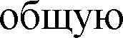

.







|  |  |  |  |  |
| --- | --- | --- | --- | --- |
|  | A | B | C | D |
| 1 |  | *i* | *i* |  |
| 2 | Pepsin | 1239 | 2 |  |
| 3 | Festal | 504 | 3 |
| 4 | Insulin | 1195 | 10 |
| 5 | Digoxin | 970 | 6 |
| 6 | Verapamil | 1017 | 4 |
| 7 | Ergotamine | 601 | 5 |
| 8 | Promethazine | 1384 | 7 |

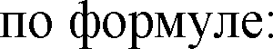

7

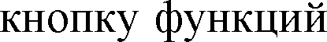*C = ki*



**D2**

**8**,

     

## D2



**8**

**:**

**8)**

**D2**

**8**







*.*



**?**

:

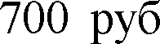

=

*bi*

= 250 000

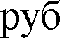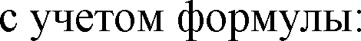

*c*

*ai*



|  |  |  |  |  |  |  |  |
| --- | --- | --- | --- | --- | --- | --- | --- |
|  | A | B | C | D | E | F | G |
| 1 |  |  | n *i* | a *i* | b *i* | c |  |
| 2 | 1 |  | 10 | 1 | 0 |  |  |
| 3 | 2 |  | 10 | 1,1 | 0 |  |  |
| 4 | 3 |  | 10 | 1,2 | 0 |  |  |
| 5 | 4 |  | 10 | 1,3 | 15 |  |  |
| 6 | 5 |  | 8 | 1,7 | 15 |  |  |
| 7 | 6 |  | 7 | 2 | 20 |  |  |
| 8 | 7 | I | 6 | 2,4 | 30 |  |  |
| 9 | 8 |  | 5 | 3,4 | 40 |  |  |
| 10 | 9 |  | 4 | 5,2 | 50 |  |  |





**-**

**13**



|  |  |  |  |
| --- | --- | --- | --- |
|  | A | B | C |
| 1 |  | 1 | 2 |
| 2 |  | 4 | 5 |
| 3 |  | 7 | 8 |
| 4 |  | 9 | 11 |
| 5 |  | 6 | 4 |
| 6 |  | 4 | 3 |
| 7 |  | 2 | 1 |
| 8 |  |  |  |
| 9 |  |  |  |
| 10 |  |  |  |
| 11 |  |  |  |
| 12 |  |  |  |
| 13 |  |  |  |
| 14 |  |  |  |



**B1:B7**

.

31

 .



.

,

.



**14**



**B1:B7**

.

**B1:B7**

.



.

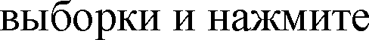

**0,05**

**B12**

**B9**

.

   









.



|  |  |  |  |
| --- | --- | --- | --- |
|  | A | B | C |
| 1 | N | X | Y |
| 2 | 1 | 78 | 121 |
| 3 | 2 | 82 | 103 |
| 4 | 3 | 74 | 99 |
| 5 | 4 | 49 | 87 |
| 6 | 5 | 106 | 110 |
| 7 | 6 | 63 | 104 |
| 8 | 7 | 72 | 98 |
| 9 | 8 | 85 | 113 |
| 10 | 9 | 59 | 77 |
| 11 | 10 | 115 | 121 |

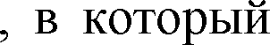

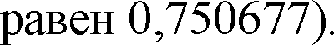

.

**F2**



|  |  |  |
| --- | --- | --- |
| **a** | **b** | **y=bx+a** |
| **F2** | .  **Ctrl+Shift+Enter**. | **G4:H8** |

a,b .

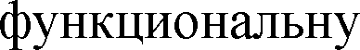

ma, mb a,b.

F**-** F**-** .

df 



|  |  |  |  |
| --- | --- | --- | --- |
| b | 0,519494 | 62,62366 | a |
| mb | 0,161646 | 13,03286 | ma |
|  | 0,563516 | 9,827388 |  |
| F | 10,32827 | 8 | df |
|  | 997,4795 | 772,6205 |  |

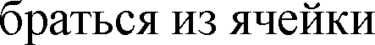

**D1**

**y\***

**y**

**D2**

**=G4*B2+H4**.

**b a**

**$**.

**D2 =$G$4*B2+$H$4**

**D11**

**$G$4**

**G4**.



 Y

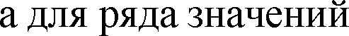Y* **-**

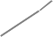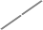

140

120

100

80

60

40

20

0

0

50

100

150



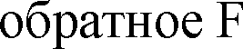

F**-**

,

**-**

.

*F-*

|  |  |  |  |
| --- | --- | --- | --- |
|  | 5,317655 |  |  |
|  |  | | |



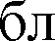

ta = a / ma , tb = b / mb

  



## df



t

=

.



|  |  |  |  |  |
| --- | --- | --- | --- | --- |
| ta | 4,80506 | tb | 3,213763 |  |
|  | 2,306004 |  |  |  |
|  | |  | | |
|  | |  | | |

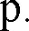 



1. *mat a m t*
2. *mbt b m t*



|  |  |  |
| --- | --- | --- |
|  | | |
| 32,56983 | alpha | 92,67748 |
| 0,146736 | beta | 0,892251 |

**:**

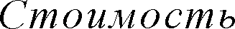

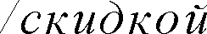

|  |  |  |  |
| --- | --- | --- | --- |
|  |  |  |  |
| ST**-**340 |  | 15456,70 | 30% |
| **-**567 |  | 350,60 | 40% |
| DI**-**328 |  | 820,50 | 35% |
| WI**-**989 | 4 | 151,20 | 20% |
| AS**-**469 |  | 2500,60 | 45% |

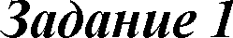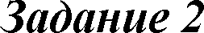



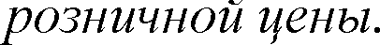

# 3 Microsoft Office Word

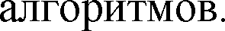Microsoft Office Word (MS Word Word) **- **,



**-**

Microsoft Office.

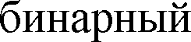

**-**

# 3.1 Word

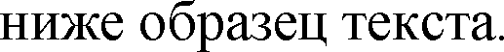

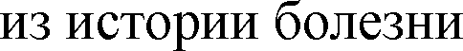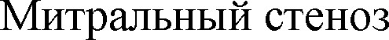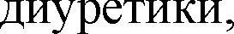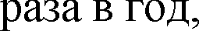

.

.

I

.

2.20

15.02.2009.

,

**-**

,

4

. **-** ,

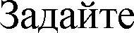

, **OK**.

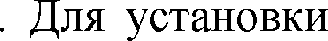

**14**

.



# 3.2

).

Microsoft Word 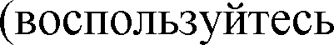 **Office**

.











**-**



.





.

   

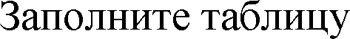/ .



.

 

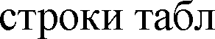

Word



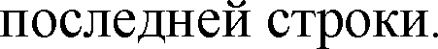. 



|  |  |  |  |  |
| --- | --- | --- | --- | --- |
|  | | |  | |
|  | / | | / | |
| 1 |  | 500 |  | 4000 |
| 2 |  | 755 |  | 650 |
| 3 |  | 310 |  | 250 |
|  | |  |  |  |



 





# 3.3 Microsoft Office Word



.



**3.3**





 **- ** **-**

.

 .

,

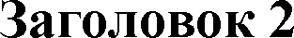

**-**

**-**







# 3.3



 Word

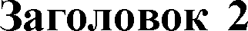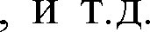

,







.



.

  



:  

.



.

  .

 .



..,



*.*

!

# 3.3







39

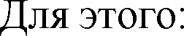



**Alt+Shift+X**.  

.

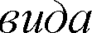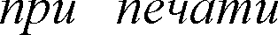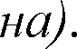

***{XE***

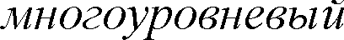

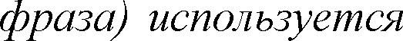

*Word*

!

 

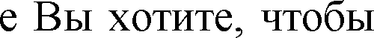

Word

.



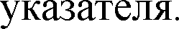

  

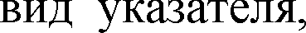.



 .

# 3.4 OLE

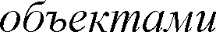

Microsoft Word

Microsoft Word

**OLE**

*Linking and Embedding*

*Object*

**OLE**

Word

Excel, PowerPoint

Microsoft Word

). Word





3

...

*xn*

(1)

2

*e*

*x*

2

2

(2)



Word

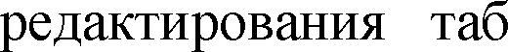

Excel Excel

Microsoft Equation

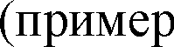

Word

Word,

Word.

**-**

Web**-**TV

HTML

.

Microsoft Excel

# 3.4





## -







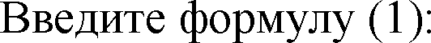3 ...

*xn* .



**-** .



  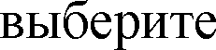

## Equation 3.0 OK.



*Word Word*

**Microsoft**



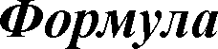

*.*

*Microsoft Equation*

!



**X = x**

**1**



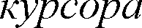

!

## : + x2 + x3 + ... + xn.

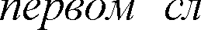

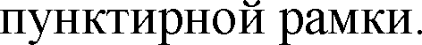

 

  



.

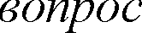 , **150%**



**OK**.



   

 **150%**.

# 3.4



Word



**ISIS/Draw**

 

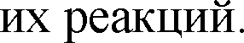

:







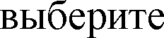**-** .

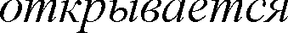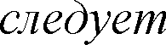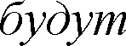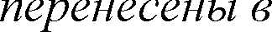

**ISIS / Draw**

**Sketch**

**OK**.

***This object has been changed****.* ***Update Microsoft Word***

*Word.*

*ISIS/Draw*

*(Freeware).*

!

O

O

n*

+ n* H

C H2

+ n* OH

2

n



.





**-**







 **OH**

## Enter.

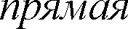

***Enter.***

***OH***

*-*

!

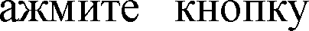

**n\***









,







: **n\***.



 





44

## HCHO.

 ,





## Enter



**CH2 -**

**CH2 -**

,

.

 **Apply**

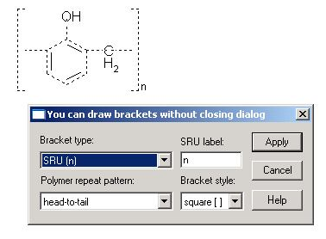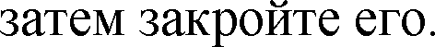



   

**? **: 

*:*

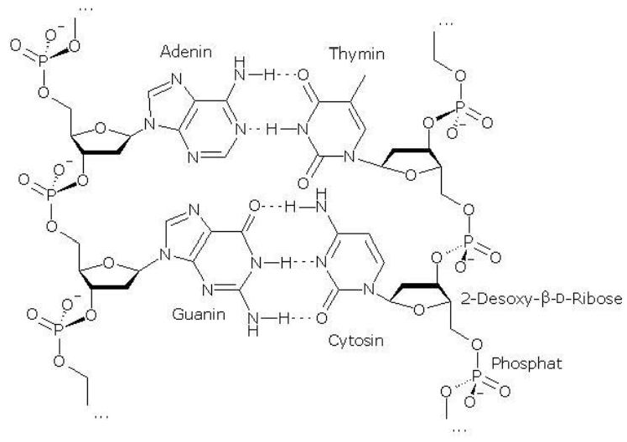

45

# 3.5.



MS Word

Word



Excel, Access Microsoft.

# 3.5.1.

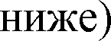

Microsoft Office Excel.





|  |  |  |  |  |  |  |  |  |
| --- | --- | --- | --- | --- | --- | --- | --- | --- |
|  | A | B | C | D | E | F | G | H |
| 1 |  |  |  |  |  |  |  |  |
| 2 |  |  | ,9 | 6,0 | 10,25 | 210,0 | 14 |  |
| 3 |  | 4 | ,80 | 5,3 | 10,25 | 170,6 | 17 |  |
| 4 |  |  | ,24 | 4,4 | 12,0 | 132,6 | 15 |  |
| 5 |  |  | 6 | 4,3 | 12,0 | 129,6 | 16 |  |
| 6 |  |  | 31 | 4,6 | 11,0 | 127,5 | 17 |  |
| 7 |  |  | 15 | 4,2 - 4,7 | 11,0 | 135,0 | 19 |  |

**3.5**







**/**

.

 

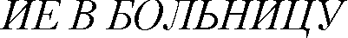

 Word



.





**?** :

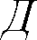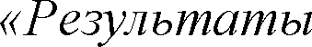

*Microsoft Access*

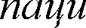

*.*

# 3



**-**



47

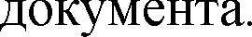



.

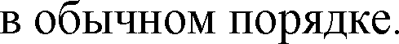



|  |  |  |
| --- | --- | --- |
|  |  |  |
|  |  | |
|  |  | |
|  |  | |
|  |  | |
|  | 101 | |
|  |  | |







  



.



.

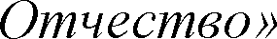

,

**101**,**103**,**107**.



.





48

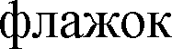

.

 **HD HDMI**



.



.

**F1**.

# 4. Microsoft Office PowerPoint

Microsoft Office PowerPoint **-**

Microsoft Office

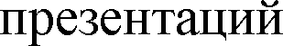

Microsoft Windows Mac OS.



MS Office

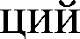

OLE

Windows



Mac OS

PDF OpenDocument.

# 4 PowerPoint

.



 

**Microsoft Office PowerPoint**.

**Microsoft Office -**

  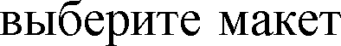 

.



  

## WordArt





.

 **-**



.

 

## WordArt

.



  





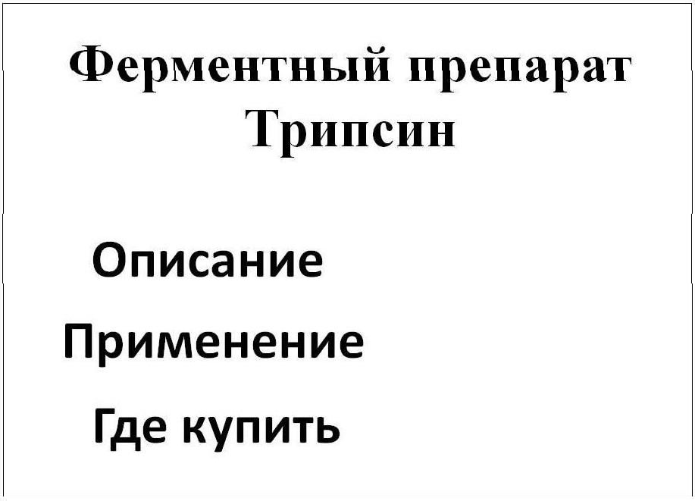

 ,



.

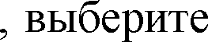

.

(



## -







 .



**,**

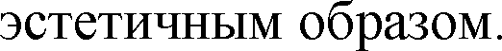

WordArt .

50

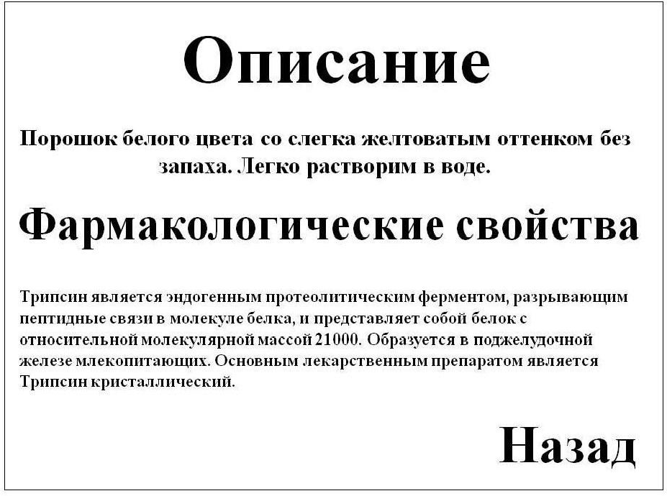



.

  









 WordArt .

51

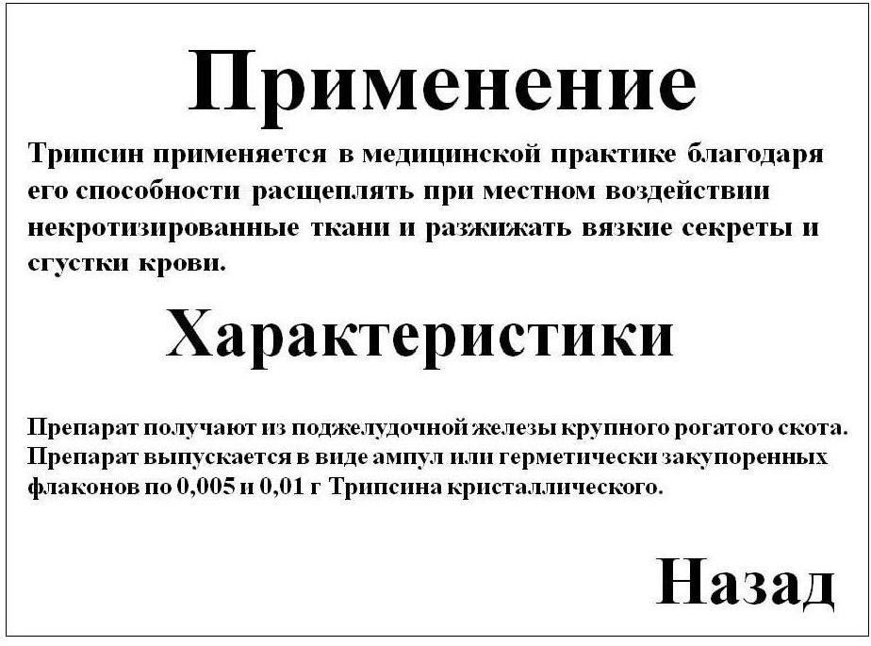

# 4



   



.

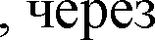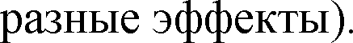

  ).

# 4







  .

,

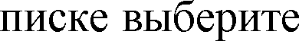

.

 .



*).*

*PowerPoint*

!

52

 .



***Esc***

!





.



.

.





 .



.

# 4



 

.



.



.

 

53



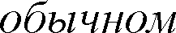



   

 .



.





    



.

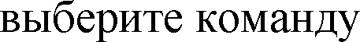

.

.



.

      

.



.















     

    

.

54

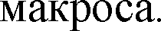  



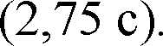

  

 

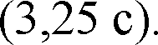





.

**-**





    

   



.

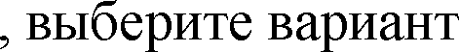

.

 



.



# 5. Web-

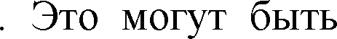

**-**

Microsoft Visual

Basic,

Microsoft Word

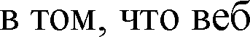

**-**

.

**-**



Microsoft Word



Microsoft

Visual Basic



Microsoft Visual Basic.







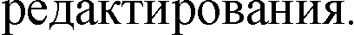

# 5.1.

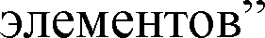

Microsoft Office Word

[*http://ru.wikipedia.org*.](http://ru.wikipedia.org/)





web**-**

*1.*

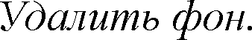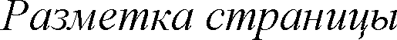

*.*

*2.*

*3.*

*4.*

*5.*

*6.*

*7. .*

*8.*

# 5

1. 

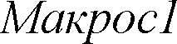

**/**

**/**

.

2.

3.



**m)**.

4.





5.



6.



.

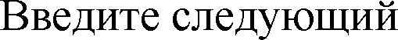(**Alt+F11)**

*'*



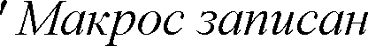 *[] Macros1 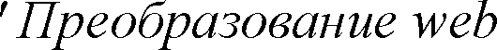-*

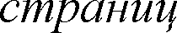*'*

*a:*

*On Error GoTo b*

*Selection.HomeKey Unit:=wdStory*

*Selection.GoTo What:=wdGoToTable, Which:=wdGoToNext, Count:=1, Name:=""*

*Selection.Rows.ConvertToText Separator:=wdSeparateByParagraphs, _ NestedTables:=True*

*GoTo a b:*

*Selection.HomeKey Unit:=wdStory With Selection.Find*

*.Text = "^g"*

*.Replacement.Text = "" End With*

*Selection.Find.Execute Replace:=wdReplaceAll*

*With Selection.Find*

*.Text = "^l"*

*.Replacement.Text = "^p" End With*

*Selection.Find.Execute Replace:=wdReplaceAll With Selection.Find*

*.Text = "^p^p"*

*.Replacement.Text = "^p" End With*

*Selection.Find.Execute Replace:=wdReplaceAll With Selection.Find*

*.Text = "^s"*

*.Replacement.Text = " " End With*

*Selection.Find.Execute Replace:=wdReplaceAll With Selection.Find*

*.Text = " "*

*.Replacement.Text = " " End With*

*Selection.Find.Execute Replace:=wdReplaceAll*



*ActiveDocument.Background.Fill.Visible = msoFalse*

*If ActiveWindow.View.SplitSpecial = wdPaneNone Then ActiveWindow.ActivePane.View.Type = wdPrintView Else*

*ActiveWindow.View.Type = wdPrintView End If*

*ActiveDocument.SaveAs FileFormat:=wdFormatDocument End Sub*

*Sub ()*

*'*

*' * 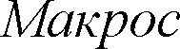

*' [] Macros1*

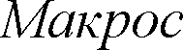

*'*

*Selection.WholeStory Selection.Font.Name = "Arial" Selection.Font.Size = 11 Selection.Font.Color = wdColorAutomatic With Selection.ParagraphFormat*

*.LeftIndent = CentimetersToPoints(0)*

*.RightIndent = CentimetersToPoints(0)*

*.SpaceBefore = 0*

*.SpaceAfter = 0*

*.LineSpacingRule = wdLineSpaceSingle*

*.FirstLineIndent = CentimetersToPoints(1.25) End With*

*Selection.HomeKey Unit:=wdStory End Sub*

**Alt + F11**.

# 5



Microsoft Word



**End**

**Help**

Microsoft Word

**Debug**

Visual Basic

.



Visual Basic





# 5.4



.

Windows



## Tools / Digital Signature





Visual Basic

.



# Microsoft Office Visio



Microsoft Office Visio:

**-**

**-**

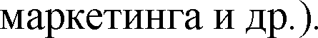

**-**

# 6.1.

[*http://www.oszone.net.*](http://www.oszone.net/)

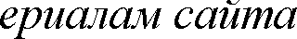

1. .

2. 



.

3.  

4. 



.

.



# 6.1.1.



1.



2. 



.

:

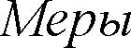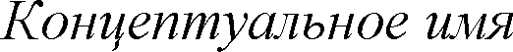

*.*

*.*

3.





4.

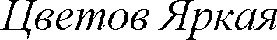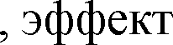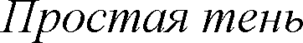

**NULL**.

**PK**

,

,

.

5.

6.

7. 

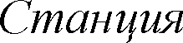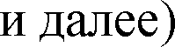

,

,

.

[*http://www.oszone.net/figs/u/72715/100330055711/image004.jpg*](http://www.oszone.net/figs/u/72715/100330055711/image004.jpg)[*http://www.oszone.net/figs/u/72715/100330055711/image005.jpg*](http://www.oszone.net/figs/u/72715/100330055711/image005.jpg)[*http://www.oszone.net/figs/u/72715/100330055711/image006.jpg*](http://www.oszone.net/figs/u/72715/100330055711/image006.jpg)[*http://www.oszone.net/figs/u/72715/100330055711/image007.jpg*](http://www.oszone.net/figs/u/72715/100330055711/image007.jpg)

# 6.1.2.



1.

2.

3.

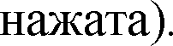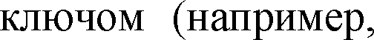

4.

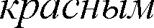

.

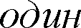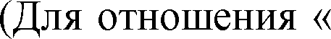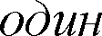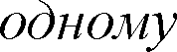

5.

.

6.

*- -*

0

*- -*

.

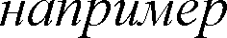

[*http://www.oszone.net/figs/u/72715/100330055711/image008.jpg*.](http://www.oszone.net/figs/u/72715/100330055711/image008.jpg)

# 6.1.3.

1.  )



.

2.   

 .

3.  

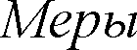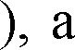

.

4. 

5.

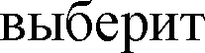

.

.

,

6.

# 6.1.4.





**65**.

1.

2.

.



3.  .

4.  

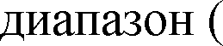

# 6.1.5.

[*http://www.oszone.net/figs/u/72715/100330055711/image010.jpg*).](http://www.oszone.net/figs/u/72715/100330055711/image010.jpg))





,

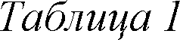

|  |  |  |
| --- | --- | --- |
|  |  |  |
| 1 |  |  |
| 2 |  |  |
| 3 |  |  |
| 4 |  |  |
| 5 |  |  |

1. 



.

2.   

.

3.

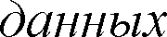

4.

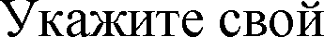5.

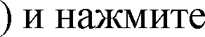

*Microsoft Access Database*

,

(

.

.

.

6.

7.

 .



.



8. ,

.

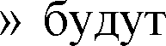

[*http://www.oszone.net/figs/u/72715/100330055711/image011.jpg*](http://www.oszone.net/figs/u/72715/100330055711/image011.jpg)[*http://www.oszone.net/figs/u/72715/100330055711/image012.jpg*](http://www.oszone.net/figs/u/72715/100330055711/image012.jpg)

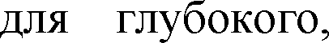

Microsoft Visio

MS Visio.

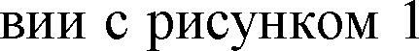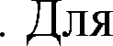

**?**

:

**-**

 **Basic Flowchart**.



,

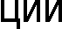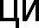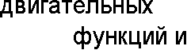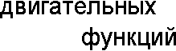

( 40 )

-

-

,

-

65

# Microsoft Office Project



 [*http://www.oszone.net.*](http://www.oszone.net/)

Microsoft Project 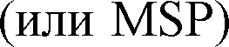 **-**



 Microsoft.

# 7.1. Microsoft Project









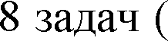

**Enter**

 [*http://www.oszone.net/figs/u/72715/100426061521/image003.jpg*),](http://www.oszone.net/figs/u/72715/100426061521/image003.jpg))

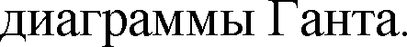

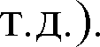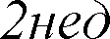







  







**-**

**-**













([*http://www.oszone.net/figs/u/72715/100426061521/image006.jpg*](http://www.oszone.net/figs/u/72715/100426061521/image006.jpg)







**-**



.



([*http://www.oszone.net/figs/u/72715/100426061521/image008.jpg*).](http://www.oszone.net/figs/u/72715/100426061521/image008.jpg))









.

**- -**

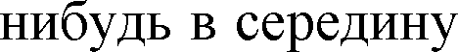

**Insert**







 

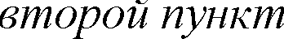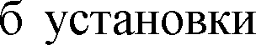

.

([*http://www.oszone.net/figs/u/72715/100426061521/image011.jpg*](http://www.oszone.net/figs/u/72715/100426061521/image011.jpg)

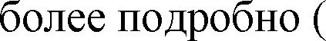

[*http://www.oszone.net/figs/u/72715/100426061521/image012.jpg*).](http://www.oszone.net/figs/u/72715/100426061521/image012.jpg))



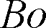*-*

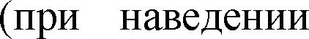

[*http://www.oszone.net/figs/u/72715/100426061521/image013.jpg*](http://www.oszone.net/figs/u/72715/100426061521/image013.jpg)

.

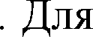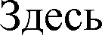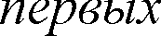

*-*



([*http://www.oszone.net/figs/u/72715/100426061521/image014.jpg*).](http://www.oszone.net/figs/u/72715/100426061521/image014.jpg))

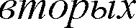

.

1.

2.

3.

*.*





# 7.2.



   



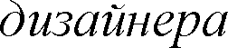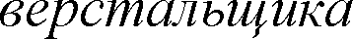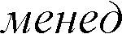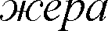

.

.

.

).

.

**100%**.

.

,

*-*

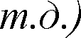

 

.



([*http://www.oszone.net/user_img/100427081344/image005.jpg*](http://www.oszone.net/user_img/100427081344/image005.jpg)

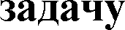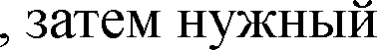

.

.





([*http://www.oszone.net/user_img/100427081344/image008.jpg*).](http://www.oszone.net/user_img/100427081344/image008.jpg))



[*http://www.oszone.net/user_img/100427081344/image009.jpg*).](http://www.oszone.net/user_img/100427081344/image009.jpg))



### Microsoft Office Access 3

 Microsoft Office Access 3

 ......................................................................................... 3

 ........................................................ 3

 ........................................................................................... 9

 ...................................................................................................................... 9

........................................................................... 10



............................................................... 10



.......................................................... 11



 ................................................................................... 11

.......................................................................................... 11

 ......................................................................12

 ................................................................... 12

......................................... 13

 ................................................... 14

 ........................................................................................................................ 15

...................................................................................................................... 15

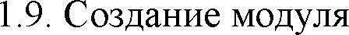 ....................................................................................................................... 16

### ................................................ 18



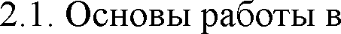 Microsoft Excel 18

 ....................................................................................................19

 ............................................................................... 21

 ....................................................................23

 .................................................................................................................... 25

 ...................................................................................................................... 26

..................................................................................... 27

........................................................................................................................ 27

2 .................................................................................. 29

2.10.  ....................................................................31

 ........................................................................................................... 32

### ..................................................... 36

 Word 36

3................................................................................................................... 37

 Microsoft Office Word 38

........................................................................................................... 38

 ............................................................................................................. 39

 ......................................................................................... 39

 OLE 40

 ............................................................................... 41

....................................................................................... 43

 ................................................................................... 46

 ............................................................................................. 46

 ........................ 46

 ................................................................................................... 47

### ............................................................... 49

 PowerPoint  .......................................................... 49

................................................................................................................. 52

................................................................................... 52

 .............................................................................................. 53

 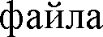 ....................................................................................................... 54

.............................................................................................................. 54

........................................................................................................54

4.5.3  ................................................................. 54

......................................... 55

### 5 - ............................................. 55



.............................................................................................. 56

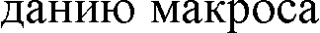

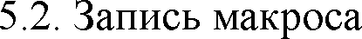 .......................................................................................................................... 56

 .................................................................................................................... 59

 ..........................................................................................................60

### Office Visio 60

 ......................................................................... 61

..................................................................................................................... 61

...................................................................................................................... 62

 ................................................................................................................. 62

................................................................................................................. 63

 ................................................................ 63

### Office Project 66

Microsoft Project 66

............................................................................................................. 69





-



II

72

04.05.2012. x

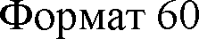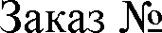

Times New Roman.

41



73